**RIPHAH INTERNATIONAL UNIVERSITY, ISLAMABAD**



**Lab 8**

**Bachelors of Computer science – 5th semester**

**Subject:** Operating System Lab

**Submitted to:** Ma’am Kausar Nasreen Khattak

**Submitted by:-** Ayiza Waqar

**Sap Id:** 44529

**Date:** 8th October, 2024

**Lab Task**

**Note:** Include screenshots, required to illustrate your explanation for all Questions.

Q1: Write a C/C++ program that uses the fork() function and the logical AND (&&) operator.

Q2: Write a C/C++ program that uses the fork() function and the logical OR (II) operator.

Q3: Write a C++ program that uses fork() to create a child process. Use an if-else statement.

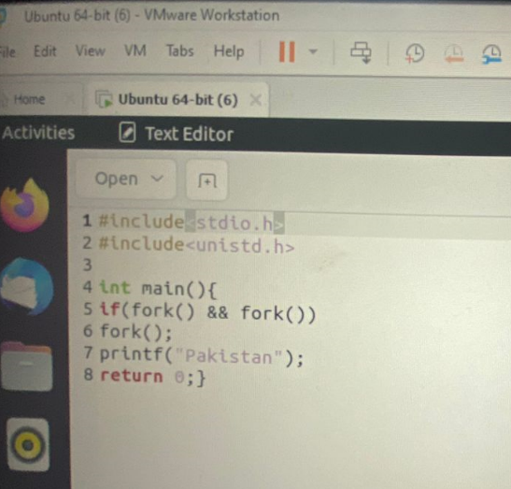

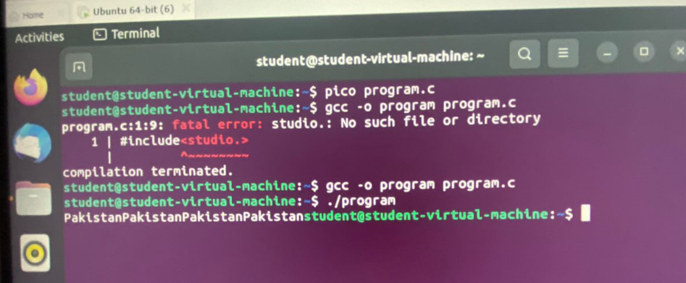

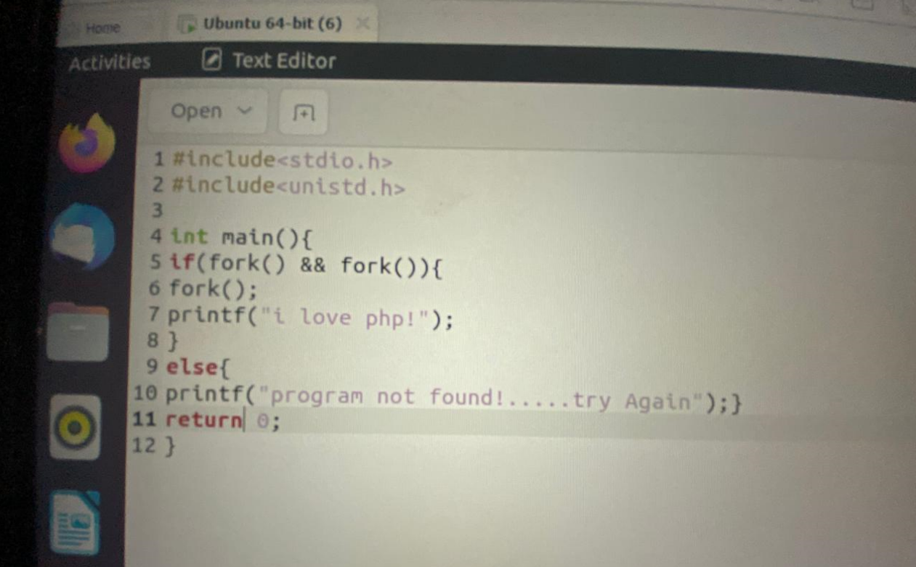 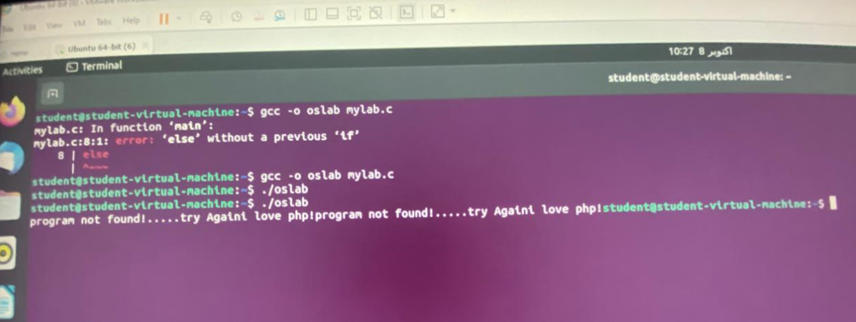

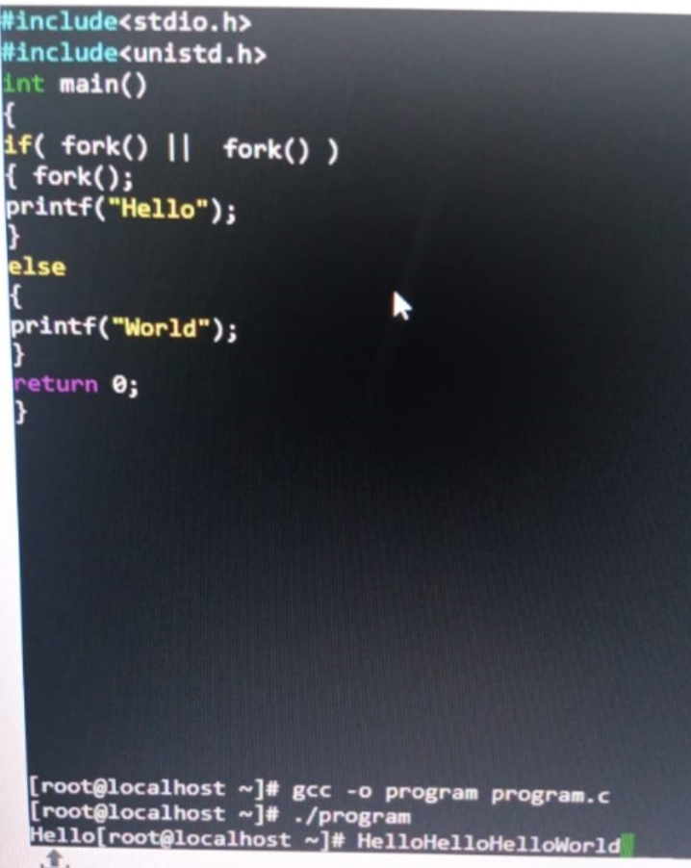

**THE END**